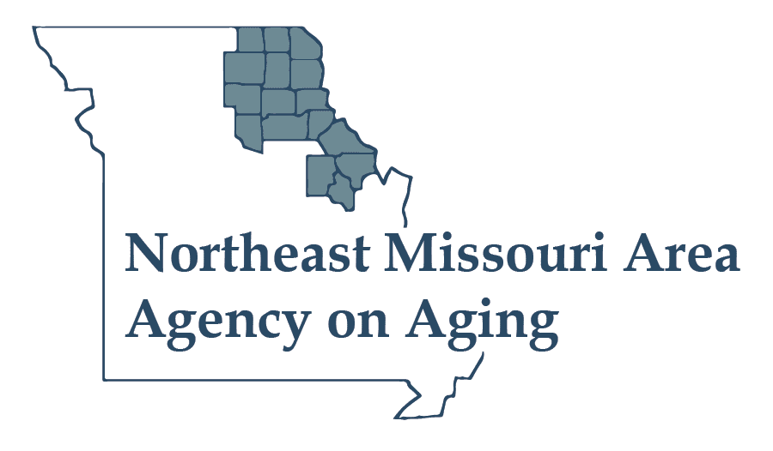
Movin’ & Groovin’ with Karen
January 13th, 20th and 27th @ 9 am
At the Schuyler County Library District
Back by popular demand is our exercise class taught by Karen Poe in conjunction with the Northeast Missouri Area Agency on Aging.

This welcoming, low-impact exercise class is designed for active adults who want to stay strong, mobile, and confident. It focuses on improving balance and stability to help with everyday activities.

Contact us to sign up and reserve your spot today as spots will be limited!
660-457-3731



**Participants are encouraged to bring their own hand and/or ankle weights if they wish as they will not be provided**

